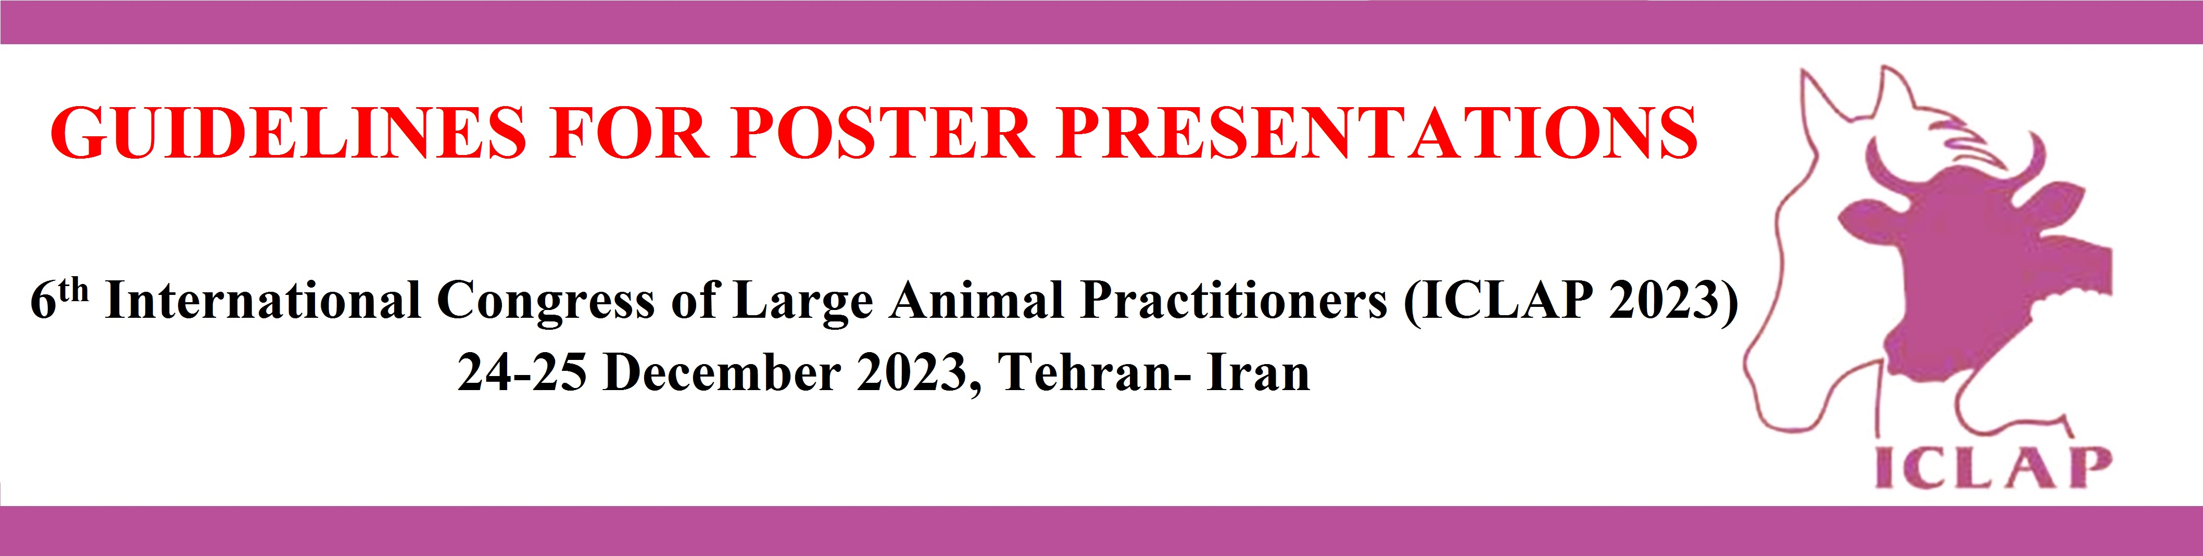

Due to limited space in poster area, posters should be posted on boards on the assigned day and hours.
- Bear in mind that a poster is a graphically based approach for presenting your research data.
- Stick to important data and not overload your poster with trivial information.
- Prepare your poster in English only.
- Prepared your poster in “portrait” orientation (long dimension is vertical).
- The entire poster will be mounted on an assigned board. It means each board has been provided with a number which is the same number as the one provided to your poster.
- Each board is 1.2 m high by 0.9 m wide. It is not necessary to fill this space up but it is your space to use. Tools for stick posters will be available at the poster site.
- Acceptable poster size is: 70 cm width × 90 cm height.
- Keep the text brief. Avoid large, continuous blocks of text
- If you can, do limit the text to about one-third to one-fourth of the poster space.
- Use bullets (phrases) to get ideas across.
- Use visuals as much as possible.
- Visuals such as diagrams, macro- and microphotographs, gel photos, charts, illustrations, genetic maps, phylogenetic trees should be simple and their text should be bold. Avoid unnecessary details.
- Present numerical data in the form of graphs, rather than tables in order to make trends in the data much more evident, If you have no option and data is needed to be presented in table-form, keep it as simple as possible.
- Make sure that any visual can “stand alone”, i. e., graph axes are properly labeled, microscopic and macroscopic lesions or gel photos have arrows and scales, symbols are explained, marker are described,etc
- Figures should be numbered consecutively in the order in which they are first mentioned in the text
- Avoid use of photographs as backgrounds that are extremely complex and make text difficult to read
- Position the following data at top-center of the poster: Your poster title, author(s), affiliation(s), e-mail addresses of presenting and corresponding authors (if they are different)
- Also include in the poster: Introduction, materials and methods, results, conclusion, and references. It means you have to answer the basic questions (what, when, where, how, why) in your poster using the following standard format:
  - Introduction (background, statement of problem, purpose/objectives)
  - Methods (experimental design, techniques)
  - Results (data summary, findings)
  - Conclusions (interpretations, implications) or next steps (if work is ongoing)
  - References (cite and reference sources of information)
- The title should be composed of CAPITAL letters.
- Try to leave some open space in the environment of poster, as open layout is less tiring to the eye and mind.
Use color to enhance comprehension (i.e., for contrast and to highlight important points), but do not decorate the poster. Use muted colors that blend well and do not overpower text or graphics
- It is recommended to use a serif font (e.g., Times New Romans) for the text, as it is easier to read. Sans-serif font (e.g., Helvetica) may be used for titles and headings, as they look better.
- You may use other standard fonts for poster preparation. But do avoid fancy fonts.
- Text should be readable from about one meter away.
- The recommended font sizes are: Poster title: 85, Main titles 72+, Sub-titles 54+, Text 30+, Sub-text 20+. In cases there is to difficult to concise the poster, the minimum accepted point for text is 18-20 pt.

Additional suggestions:

- Before begin to prepare your poster, first make a list of the visuals that is needed to be used. Write the text after you have created the list of visuals. It is a very important point in making a great poster.
- Before coming to your poster session, rehearse a brief summary of your research project. Many viewers will be in a hurry and may want a quick “guided tour” of your poster.
- Don’t be afraid to point out uncertainties in your work; this is where you may get useful feedback from senior and young scientists and even students.

If you like to provide eager viewers or special viewers with a supplemental information you can do it (i.e., abstract, paper copies of the poster, list of references or whatever)

